# Exercise: Recursion in Java

This document defines in-class exercise problems from the [“Java Fundamentals“ Course @ Software University](https://softuni.bg/trainings/1232/java-fundamentals-october-2015). You are presented with some problems and certain steps you need to take in order to accomplish the tasks.

## Problem 1. Print Numbers from 1 to N Using Recursion

Printing numbers is quite easy. You must be familiar with the usual way of using a for/while loop. Recursion may be a little difficult to grasp at first. It is actually a method that calls itself with updated arguments. The method will continue calling itself until the argument reaches its base case. At that point, the method starts returning the accumulated values. In our case, those values will be simple integers.

### Step 1. Read and Process the Input

First, we need to take int N from the console. This is done with a simple Scanner:

C:\Users\Edu\Pictures\inputrecursive.JPG

### Step 2. Create the Recursive Method

To use recursion, we need a method. Create a simple method printRecursive(int n) that calls itself with (n – 1) until the number **n** is smaller than 1. For instance, if **n** is equal to 5, in the stack we will have:

printRecursive(1)

printRecursive(2)

printRecursive(3)

printRecursive(4)

printRecursive(5)

When we call printRecursive(0), the program flow will enter the base case, which will stop it. At that point, the methods that are pushed into the stack will start returning their values. Since a stack always returns the element at the top, the first returned value will be 1, the next will be 2, and so on. Print those values:

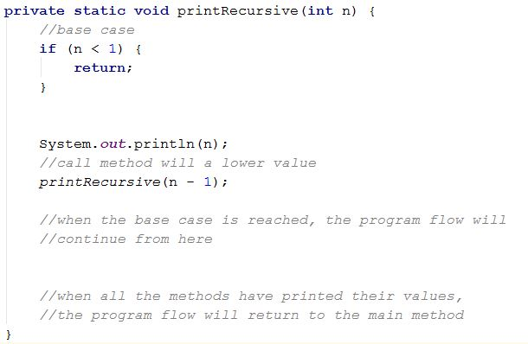

All you need to do is call the method from main() with the initial value.

*If you move the println() call before the recursive call, you will notice that the numbers are printed from top to bottom (5, 4, 3, 2, 1), instead of (1, 2, 3, 4, 5).* ***Think why.***

|  |  |
| --- | --- |
| **Input** | **Output** |
| 5 | 1  2  3  4  5 |